**Government Polytechnic Solapur**

**MICROPROJECT**

**Mobile Application Development (22617)**

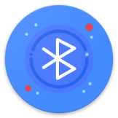**PROJECT TOPIC – *Bluechat***

**2021-2022**

**CERTIFICATE** 

Maharashtra State Board Of Technical Education, Mumbai

GOVERNMENT POLYTECHNICS, SOLAPUR

**Subject: Mobile Application Development(22617)**

***Topic :- Bluechat***

Submitted by:

|  |  |
| --- | --- |
| **Roll No.** | **Name** |
| 52 | Sufiyan Sajid Shaikh |

Of third semester of diploma in Computer in Technology of institute **Government** **Polytechnic, Solapur (0015)** have completed the micro project work satisfactorily under the guidance of **Ms. S.S. Dhawre** in the academic year 2021-2022 as prescribed in the I-Scheme curriculum

Project guide H.O.D Principal

Acknowledgement

We wish to express our profound and sincere gratitude to our guide **Ms. S.S. Dhawre** who guided us in the structure of micro project as well as some main points in that micro project also they cleared our all doubts about micro project .We are Indebted to his constant encouragement, co-operation and help .It was his enthusiastic support that helped us in overcoming various obstacles in the project.

We would also like to express our thankfulness to our beloved Principal as well as HOD and other faculty members of our second-year department for extending their support and motivation

Finally, we completed our micro project that regarding to our syllabus as well as department, once more thanks for all Group members**, Principal, HOD** and other Faculty Members who helped us in the micro project completion.

Thanks!!

**PART A – Micro-Project Proposal**

***Bluechat***

**1.0 Brief Introduction**

In this micro-project I developed a android application in which you can chat with anyone using Bluetooth

**2.0 Aim of the Micro-Project** (in about 1 to 2 Sentences)

Aim of this micro-project is to develop a Mobile Application using it 2 people can chat by connecting mobile using Bluetooth.

**3.0 Intended Course Outcomes**

1. Interpreted features of Android operating system.
2. Configure android environment and development tools.
3. Develop rich user interfaces by using layout and controls.
4. Use User Interface components for android application development.

**4.0 Literature Review**

We searched information for the suggested topic by our industry guide. Collected the data required for the project. We did some experiments to make different models easier to understand.

**5.0 Proposed Methodology**

1. First searched for the suggested micro-project.
2. Collected information for the suggested topic.
3. Started for the micro-project.
4. Completed micro-project.
5. Showed to respected teacher.
6. Teacher regarded of some changes.
7. Done the changes into the project as told by teacher.

**6.0 Resources Required.**

|  |  |  |  |  |
| --- | --- | --- | --- | --- |
| **S. No.** | **Name of Resource/material** | **Specifications** | **Qty** | **Remarks** |
|  | Laptop / PC | Windows 10 | 2 | - |
|  | Internet | Website | 1 | - |
|  | Printer | HP inkjet 120 plus | 1 |  |
|  |  |  |  |  |

**7.0 Action Plan** (Sequence and time required for major activities for 8 Weeks)

|  |  |  |  |
| --- | --- | --- | --- |
| **S. No.** | **Details of activity** | **Planned Start date** | **Planned Finish date** |
|  | Searched for topic of micro-project | 20/03/2022 | 24/03/2022 |
|  | Topic searched:-   1. PDF viewer 2. bluechat | 24/03/2022 | 30/03/2022 |
|  | Discussed with teacher about the topic | 30/03/2022 | 1/03/2022 |
|  | Teacher approved for bluechat | 1/04/2022 | 1/04/2022 |
|  | Created prototype of our project | 3/04/2022 | 04/04/2022 |
|  | Started for developing the activities | 15/04/2022 | 20/04/2022 |
|  | Created activities | 15/04/2022 | 20/04/2022 |
|  | Linked each of the pages to each other also to index page | 15/04/2022 | 20/04/2022 |
|  | Completed the total application | 20/04/2022 | 22/04/2022 |
|  | Showed Application to teacher and she suggested some corrections | 24/04/2022 | 24/04/2022 |
|  | We made the suggested correction | 25/04/2022 | 28/04/2022 |
|  | Teacher approved the application | 30/04/2022 | 1/05/2022 |

Abstract

In this micro project I developed an Android application named bluechat. Using this application 2 people can chat with each other using Bluetooth. This application allows user to Host a chat room. This room can be joined by Connecting to that device using Bluetooth from application. After connecting User can send and receive text messages.

In this application I have used Bluetooth to establish connection between devices. It uses inbuild Bluetooth Adapter to communicate to other devices. User can host a connection or Request to for connection to a device. That device can a paired device or a new Bluetooth device.

|  |  |  |
| --- | --- | --- |
| Sr. No. | Title | Page no. |
| 1 | Introduction | 6 |
| 2 | Aim | 8 |
| 3 | Course Outcomes | 8 |
| 4 | Literature Review | 8 |
| 5 | Actual Methodology | 8 |
| 7 | Actual Resource | 11 |
| 8 | Output | 11 |
| 9 | Skill Developed | 14 |
| 10 | Application | 15 |
| 11 | Area of Future | 15 |
| 12 | Conclusion | 16 |
| 13 | Reference | 17 |

**Index**

**PART B – Micro-Project Report**

**Title of Micro-Project:**

***Bluechat***

1. **Rationale**

In this micro project I developed an Android application named bluechat. Using this application 2 people can chat with each other using Bluetooth. This application allows user to Host a chat room. This room can be joined by Connecting to that device using Bluetooth from application. After connecting User can send and receive text messages.

1. **Course Outcomes Addressed**
   1. Interpreted features of Android operating system.
   2. Configure android environment and development tools.
   3. Develop rich user interfaces by using layout and controls.
   4. Use User Interface components for android application development.
2. **Literature Review**

**Bluetooth** is a short-range wireless technology standard that is used for exchanging data between fixed and mobile devices over short distances using UHF radio waves in the ISM bands, from 2.402 GHz to 2.48 GHz, and building personal area networks (PANs).[]](https://en.wikipedia.org/wiki/Bluetooth#cite_note-Muller-3) It is mainly used as an alternative to wire connections, to exchange files between nearby portable devices and connect cell phones and music players with wireless headphones. In the most widely used mode, transmission power is limited to 2.5 milliwatts, giving it a very short range of up to 10 metres (33 ft).

Universally Unique Identifiers, or UUIDS, are 128 bit numbers, composed of 16 octets and represented as 32 base-16 characters, that can be used to identify information across a computer system. This specification was originally created by Microsoft and standardized by both the IETF and ITU

On the client side, use a single BluetoothSocket to both initiate an outgoing connection and to manage the connection. The most common type of Bluetooth socket is RFCOMM, which is the type supported by the Android APIs. RFCOMM is a connection-oriented, streaming transport over Bluetooth.

1. **Actual Methodology Followed** 
   * + 1. Create New project in Android Studio
       2. Imported required images in drawable folder
       3. Created activities for Requesting and Hosting
       4. Write necessary code in Activates
       5. Created Intents to go to next Activity
       6. Added BLUETOOTH permissions in AndroidManifest.xml
       7. Created User Interface
       8. Build Application
       9. Tested Application

**5.0 Resources Required**

|  |  |  |  |  |
| --- | --- | --- | --- | --- |
| **S. No.** | **Name of Resource/material** | **Specifications** | **Qty** | **Remarks** |
|  | *Android Studio* | 2019 | 1 |  |
|  | *Bluetooth device* | Any | 1 |  |
|  | *Android Device* | API level 21 or higher | 1 |  |
|  | *Laptop/pc with Internet connection* | Windows 10/minimum 2Mbps speed | 1 |  |

**6.0 Output of Micro-project**

**6.1 Source code : -**

**Android_manifest.xml**

<?xml version="1.0" encoding="utf-8"?>

<manifest xmlns:android="http://schemas.android.com/apk/res/android"

package="com.example.bluechat">

<uses-permission android:name="android.permission.BLUETOOTH" />

<uses-permission android:name="android.permission.BLUETOOTH_ADMIN" />

<uses-permission android:name="android.permission.BLUETOOTH_ADVERTISE" />

<uses-permission android:name="android.permission.BLUETOOTH_CONNECT" />

<uses-permission android:name="android.permission.BLUETOOTH_SCAN" />

<uses-permission android:name="android.permission.ACCESS_COARSE_LOCATION" />

<uses-permission android:name="android.permission.ACCESS_FINE_LOCATION" />

<application

android:allowBackup="true"

android:icon="@mipmap/ic_launcher"

android:label="@string/app_name"

android:roundIcon="@mipmap/ic_launcher"

android:supportsRtl="true"

android:theme="@style/Theme.Bluechat">

<activity android:name=".Chat"/>

<activity android:name=".HostConnection" />

<activity android:name=".searchDevice" />

<activity android:name=".MainActivity">

<intent-filter>

<action android:name="android.intent.action.MAIN" />

<category android:name="android.intent.category.LAUNCHER" />

</intent-filter>

</activity>

</application>

</manifest>

**Activity_main.xml**

<?xml version="1.0" encoding="utf-8"?>

<androidx.constraintlayout.widget.ConstraintLayout xmlns:android="http://schemas.android.com/apk/res/android"

xmlns:app="http://schemas.android.com/apk/res-auto"

xmlns:tools="http://schemas.android.com/tools"

android:layout_width="match_parent"

android:layout_height="match_parent"

tools:context=".MainActivity">

<ImageButton

android:id="@+id/send"

android:layout_width="92dp"

android:layout_height="89dp"

android:tooltipText="Request"

android:background="@color/green"

android:src="@drawable/link_coloured"

app:layout_constraintBottom_toBottomOf="parent"

app:layout_constraintEnd_toEndOf="parent"

app:layout_constraintHorizontal_bias="0.216"

app:layout_constraintStart_toStartOf="parent"

app:layout_constraintTop_toTopOf="parent"

app:layout_constraintVertical_bias="0.386" />

<TextView

android:layout_width="wrap_content"

android:layout_height="wrap_content"

android:text="Request"

android:textSize="25sp"

android:textStyle="bold"

app:layout_constraintBottom_toBottomOf="parent"

app:layout_constraintEnd_toEndOf="parent"

app:layout_constraintHorizontal_bias="0.213"

app:layout_constraintStart_toStartOf="parent"

app:layout_constraintTop_toBottomOf="@+id/send"

app:layout_constraintVertical_bias="0.058" />

<ImageButton

android:id="@+id/recieve"

android:layout_width="92dp"

android:layout_height="89dp"

android:background="@color/green"

android:src="@drawable/host_icon"

app:layout_constraintBottom_toBottomOf="parent"

app:layout_constraintEnd_toEndOf="parent"

app:layout_constraintHorizontal_bias="0.575"

app:layout_constraintStart_toEndOf="@+id/send"

app:layout_constraintTop_toTopOf="parent"

app:layout_constraintVertical_bias="0.385" />

<TextView

android:layout_width="wrap_content"

android:layout_height="wrap_content"

android:text="Host"

android:textSize="25sp"

android:textStyle="bold"

app:layout_constraintBottom_toBottomOf="parent"

app:layout_constraintEnd_toEndOf="parent"

app:layout_constraintHorizontal_bias="0.759"

app:layout_constraintStart_toStartOf="parent"

app:layout_constraintTop_toBottomOf="@+id/recieve"

app:layout_constraintVertical_bias="0.06" />

<TextView

android:layout_width="wrap_content"

android:layout_height="wrap_content"

android:text="Developed By : github.com/SEGRR"

app:layout_constraintBottom_toBottomOf="parent"

app:layout_constraintEnd_toEndOf="parent"

app:layout_constraintStart_toStartOf="parent" />

</androidx.constraintlayout.widget.ConstraintLayout>

**MainActivity.java**

package com.example.bluechat;

import androidx.appcompat.app.AppCompatActivity;

import androidx.core.app.ActivityCompat;

import androidx.core.content.ContextCompat;

import android.Manifest;

import android.bluetooth.BluetoothAdapter;

import android.content.Intent;

import android.content.pm.PackageManager;

import android.os.Bundle;

import android.view.View;

import android.widget.ImageButton;

import android.widget.Toast;

import java.util.ArrayList;

public class MainActivity extends AppCompatActivity {

ImageButton send,receive;

BluetoothAdapter bt;

ArrayList<String> arrayList;

@Override

protected void onCreate(Bundle savedInstanceState) {

super.onCreate(savedInstanceState);

setContentView(R.layout.activity_main);

send = findViewById(R.id.send);

bt = BluetoothAdapter.getDefaultAdapter();

arrayList = new ArrayList<>();

receive = findViewById(R.id.recieve);

send.setOnClickListener(new View.OnClickListener() {

@Override

public void onClick(View view) {

if(bt == null)

{

Toast.makeText(MainActivity.this, "THIS DEVICE DOES NOT SUPPORT BLUETOOTH", Toast.LENGTH_LONG).show();

}else {

if(!bt.isEnabled()){

Intent intent = new Intent(BluetoothAdapter.ACTION_REQUEST_ENABLE);

accesspermission();

}

Intent intent = new Intent(MainActivity.this,searchDevice.class);

bt.enable();

startActivity(intent);

}

}

});

receive.setOnClickListener(new View.OnClickListener() {

@Override

public void onClick(View view) {

Intent intent = new Intent(MainActivity.this,HostConnection.class);

bt.enable();

startActivity(intent);

}

});

}

public void accesspermission(){

if(ContextCompat.checkSelfPermission(this, Manifest.permission.ACCESS_FINE_LOCATION) != PackageManager.PERMISSION_GRANTED){

ActivityCompat.requestPermissions(this,new String[]{Manifest.permission.ACCESS_FINE_LOCATION},1);

}

if(ContextCompat.checkSelfPermission(this, Manifest.permission.ACCESS_COARSE_LOCATION) != PackageManager.PERMISSION_GRANTED){

ActivityCompat.requestPermissions(this,new String[]{Manifest.permission.ACCESS_COARSE_LOCATION},2);

}

if(ContextCompat.checkSelfPermission(this, Manifest.permission.BLUETOOTH_ADMIN) != PackageManager.PERMISSION_GRANTED){

ActivityCompat.requestPermissions(this,new String[]{Manifest.permission.BLUETOOTH_ADMIN},3);

}

}

}

**Activity_search_devices.xml**

<?xml version="1.0" encoding="utf-8"?>

<androidx.constraintlayout.widget.ConstraintLayout xmlns:android="http://schemas.android.com/apk/res/android"

xmlns:app="http://schemas.android.com/apk/res-auto"

xmlns:tools="http://schemas.android.com/tools"

android:layout_width="match_parent"

android:layout_height="match_parent"

tools:context=".searchDevice">

<TextView

android:id="@+id/textView"

android:layout_width="wrap_content"

android:layout_height="wrap_content"

android:text="Available Devices"

android:textSize="25sp"

android:textStyle="bold"

app:layout_constraintBottom_toBottomOf="parent"

app:layout_constraintEnd_toEndOf="parent"

app:layout_constraintHorizontal_bias="0.49"

app:layout_constraintStart_toStartOf="parent"

app:layout_constraintTop_toTopOf="parent"

app:layout_constraintVertical_bias="0.049" />

<TextView

android:id="@+id/textView2"

android:layout_width="wrap_content"

android:layout_height="wrap_content"

android:text="Searching for Nearby Devices"

android:textSize="20sp"

app:layout_constraintBottom_toBottomOf="parent"

app:layout_constraintEnd_toEndOf="parent"

app:layout_constraintHorizontal_bias="0.28"

app:layout_constraintStart_toStartOf="parent"

app:layout_constraintTop_toTopOf="parent"

app:layout_constraintVertical_bias="0.937" />

<ListView

android:id="@+id/devices_list"

android:layout_width="377dp"

android:layout_height="513dp"

app:layout_constraintBottom_toBottomOf="parent"

app:layout_constraintEnd_toEndOf="parent"

app:layout_constraintHorizontal_bias="0.4"

app:layout_constraintStart_toStartOf="parent"

app:layout_constraintTop_toTopOf="parent"

app:layout_constraintVertical_bias="0.444" />

<ProgressBar

android:id="@+id/progressBar2"

style="?android:attr/progressBarStyle"

android:layout_width="39dp"

android:layout_height="48dp"

app:layout_constraintBottom_toBottomOf="parent"

app:layout_constraintEnd_toEndOf="parent"

app:layout_constraintHorizontal_bias="0.439"

app:layout_constraintStart_toEndOf="@+id/textView2"

app:layout_constraintTop_toTopOf="parent"

app:layout_constraintVertical_bias="0.951" />

</androidx.constraintlayout.widget.ConstraintLayout>

**SearchDevices.java**

package com.example.bluechat;

import androidx.appcompat.app.AppCompatActivity;

import android.bluetooth.BluetoothAdapter;

import android.bluetooth.BluetoothDevice;

import android.bluetooth.BluetoothSocket;

import android.content.BroadcastReceiver;

import android.content.Context;

import android.content.Intent;

import android.os.Bundle;

import android.os.Handler;

import android.util.Log;

import android.view.View;

import android.widget.AdapterView;

import android.widget.ArrayAdapter;

import android.widget.ListView;

import android.widget.Toast;

import java.io.IOException;

import java.util.ArrayList;

import java.util.Set;

import java.util.UUID;

public class searchDevice extends AppCompatActivity {

BluetoothAdapter bt;

ArrayList<BluetoothDevice> availableDevices;

ArrayAdapter<String> device_list;

ArrayList<String> arrayList;

BroadcastReceiver receiver;

ListView lv;

BluetoothSocket mmSocket;

UUID uuid;

String connected_device;

Handler handler;

public static BluetoothSocket bluetoothSocket;

@Override

protected void onCreate(Bundle savedInstanceState) {

super.onCreate(savedInstanceState);

setContentView(R.layout.activity_search_device);

uuid = UUID.fromString("a2932642-bd7e-11ec-9d64-0242ac120002");

availableDevices = new ArrayList<>();

arrayList = new ArrayList<>();

lv = findViewById(R.id.devices_list);

bt = BluetoothAdapter.getDefaultAdapter();

handler = new Handler();

Set<BluetoothDevice> pairedDevices = bt.getBondedDevices();

if(!bt.isEnabled())

bt.enable();

if(pairedDevices.size() > 0) {

for (BluetoothDevice device : pairedDevices) {

availableDevices.add(device);

arrayList.add(device.getName());

}

}

device_list = new ArrayAdapter<String>(searchDevice.this,android.R.layout.simple_list_item_1,arrayList);

lv.setAdapter(device_list);

receiver = new BroadcastReceiver() {

public void onReceive(Context context, Intent intent) {

String action = intent.getAction();

if (BluetoothDevice.ACTION_FOUND.equals(action)) {

BluetoothDevice device = intent.getParcelableExtra(BluetoothDevice.EXTRA_DEVICE);

availableDevices.add(device);

arrayList.add(device.getName());

//Log.i("Bluetooth Devices : ",device.getName());

device_list.notifyDataSetChanged();

}

}

};

lv.setOnItemClickListener(new AdapterView.OnItemClickListener() {

@Override

public void onItemClick(AdapterView<?> adapterView, View view, int i, long l) {

// Toast.makeText(searchDevice.this, ""+i, Toast.LENGTH_SHORT).show();

BluetoothDevice selectedDevice = availableDevices.get(i);

connected_device = selectedDevice.getName();

Toast.makeText(searchDevice.this, "Connecting To "+selectedDevice.getName(), Toast.LENGTH_SHORT).show();

BluetoothSocket tmp = null;

try {

// Get a BluetoothSocket to connect with the given BluetoothDevice.

// MY_UUID is the app's UUID string, also used in the server code.

tmp = selectedDevice.createRfcommSocketToServiceRecord(uuid);

} catch (IOException e) {

Log.e("ERROR", "Socket's create() method failed", e);

}

mmSocket = tmp;

Thread connectToDevice = new Thread(new Runnable() {

@Override

public void run() {

// bt.cancelDiscovery();

try {

mmSocket.connect();

if(mmSocket.isConnected()){

manageMyConnectedSocket(mmSocket);

}

} catch (IOException connectException) {

try {

mmSocket.close();

} catch (IOException closeException) {

Log.e("ERROR", "Could not close the client socket", closeException);

Toast.makeText(searchDevice.this, "Cannot connect to This device", Toast.LENGTH_SHORT).show();

}

}

}

});

connectToDevice.start();

}

});

}

public void manageMyConnectedSocket(BluetoothSocket mmSocket){

bluetoothSocket = mmSocket;

Intent intent = new Intent(getApplicationContext(),Chat.class);

intent.putExtra("connected_device",connected_device);

startActivity(intent);

}

public void onDestroy(){

super.onDestroy();

unregisterReceiver(receiver);

}

}

**Activity_host_connection.xml**

<?xml version="1.0" encoding="utf-8"?>

<androidx.constraintlayout.widget.ConstraintLayout xmlns:android="http://schemas.android.com/apk/res/android"

xmlns:app="http://schemas.android.com/apk/res-auto"

xmlns:tools="http://schemas.android.com/tools"

android:layout_width="match_parent"

android:layout_height="match_parent"

tools:context=".HostConnection">

<TextView

android:layout_width="wrap_content"

android:layout_height="wrap_content"

android:text="Waiting For Connection"

android:textSize="30sp"

android:textStyle="bold"

app:layout_constraintBottom_toBottomOf="parent"

app:layout_constraintEnd_toEndOf="parent"

app:layout_constraintStart_toStartOf="parent"

app:layout_constraintTop_toTopOf="parent" />

</androidx.constraintlayout.widget.ConstraintLayout>

Activity_chat.xml

<?xml version="1.0" encoding="utf-8"?>

<androidx.constraintlayout.widget.ConstraintLayout xmlns:android="http://schemas.android.com/apk/res/android"

xmlns:app="http://schemas.android.com/apk/res-auto"

xmlns:tools="http://schemas.android.com/tools"

android:layout_width="match_parent"

android:layout_height="match_parent"

tools:context=".Chat">

<ScrollView

android:layout_width="409dp"

android:layout_height="192dp"

app:layout_constraintBottom_toBottomOf="parent"

app:layout_constraintTop_toTopOf="parent"

app:layout_constraintVertical_bias="0.051"

tools:layout_editor_absoluteX="-2dp">

<TextView

android:id="@+id/displaymsg"

android:layout_width="match_parent"

android:layout_height="match_parent"

android:textSize="20dp" />

</ScrollView>

<EditText

android:hint="Enter message"

android:id="@+id/msg"

android:layout_width="match_parent"

android:layout_height="wrap_content"

app:layout_constraintBottom_toBottomOf="parent"

app:layout_constraintTop_toTopOf="parent"

app:layout_constraintVertical_bias="0.654"

tools:layout_editor_absoluteX="1dp" />

<Button

android:id="@+id/sendbtn"

android:layout_width="wrap_content"

android:layout_height="wrap_content"

android:text="Send"

android:textSize="23dp"

app:layout_constraintBottom_toBottomOf="parent"

app:layout_constraintEnd_toEndOf="parent"

app:layout_constraintHorizontal_bias="0.128"

app:layout_constraintStart_toStartOf="parent"

app:layout_constraintTop_toTopOf="parent"

app:layout_constraintVertical_bias="0.836" />

<Button

android:id="@+id/closeConnectionbtn"

android:layout_width="wrap_content"

android:layout_height="wrap_content"

android:text="Close connection"

app:layout_constraintBottom_toBottomOf="parent"

app:layout_constraintEnd_toEndOf="parent"

app:layout_constraintHorizontal_bias="0.928"

app:layout_constraintStart_toStartOf="parent"

app:layout_constraintTop_toTopOf="parent"

app:layout_constraintVertical_bias="0.834" />

</androidx.constraintlayout.widget.ConstraintLayout>

**Chat.java**

package com.example.bluechat;

import androidx.appcompat.app.AppCompatActivity;

import android.bluetooth.BluetoothSocket;

import android.content.Intent;

import android.os.Bundle;

import android.os.Handler;

import android.view.View;

import android.widget.Button;

import android.widget.EditText;

import android.widget.TextView;

import android.widget.Toast;

import java.io.DataInputStream;

import java.io.DataOutputStream;

import java.io.IOException;

public class Chat extends AppCompatActivity {

Button send,closeConnection;

TextView msgbox;

EditText msginput;

DataInputStream input;

DataOutputStream output;

Handler handler,inputHandler;

String deviceName;

public static BluetoothSocket bs;

@Override

protected void onCreate(Bundle savedInstanceState) {

super.onCreate(savedInstanceState);

setContentView(R.layout.activity_chat);

Toast.makeText(this, "Connection complete", Toast.LENGTH_SHORT).show();

send = findViewById(R.id.sendbtn);

closeConnection = findViewById(R.id.closeConnectionbtn);

msgbox = findViewById(R.id.displaymsg);

msginput = findViewById(R.id.msg);

deviceName = getIntent().getStringExtra("connected_device");

if(HostConnection.bluetoothSocket == null)

bs= searchDevice.bluetoothSocket;

else

bs = HostConnection.bluetoothSocket;

try {

input = new DataInputStream(bs.getInputStream());

output = new DataOutputStream(bs.getOutputStream());

handler = new Handler();

inputHandler = new Handler();

send.setOnClickListener(new View.OnClickListener() {

@Override

public void onClick(View view) {

String msg = msginput.getText().toString();

if(msg.length() < 1){

Toast.makeText(Chat.this, "Enter message first ", Toast.LENGTH_SHORT).show();

}else{

Toast.makeText(Chat.this, "Sending...", Toast.LENGTH_SHORT).show();

new Thread(new Runnable() {

@Override

public void run() {

try{

output.writeUTF(msg);

}catch(Exception e) {

e.printStackTrace();

}

handler.post(new Runnable() {

@Override

public void run() {

String data = msgbox.getText().toString();

data += "\nME : "+msg;

msgbox.setText(data);

Toast.makeText(Chat.this, "Sent", Toast.LENGTH_SHORT).show();

}

});

}

}).start();

}

}

});

closeConnection.setOnClickListener(new View.OnClickListener() {

@Override

public void onClick(View view) {

Toast.makeText(Chat.this, "Closing Connection", Toast.LENGTH_SHORT).show();

try{

bs.close();

Intent intent = new Intent(Chat.this,MainActivity.class);

startActivity(intent);

}catch (Exception e){

e.printStackTrace();

}

}

});

new Thread(new Runnable() {

@Override

public void run() {

while(bs.isConnected()){

try{

String inputmsg = input.readUTF();

inputHandler.post(new Runnable() {

@Override

public void run() {

String data = msgbox.getText().toString();

data += "\n"+ deviceName +" : "+inputmsg;

msgbox.setText(data);

}

});

}catch (Exception e){

e.printStackTrace();

}

}

}

}).start();

} catch (IOException e) {

Toast.makeText(this, "Cannot create streams", Toast.LENGTH_SHORT).show();

e.printStackTrace();

}

}

}

**6.2 Output of project**

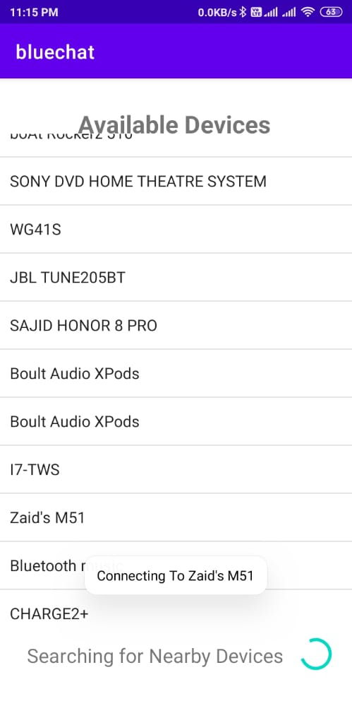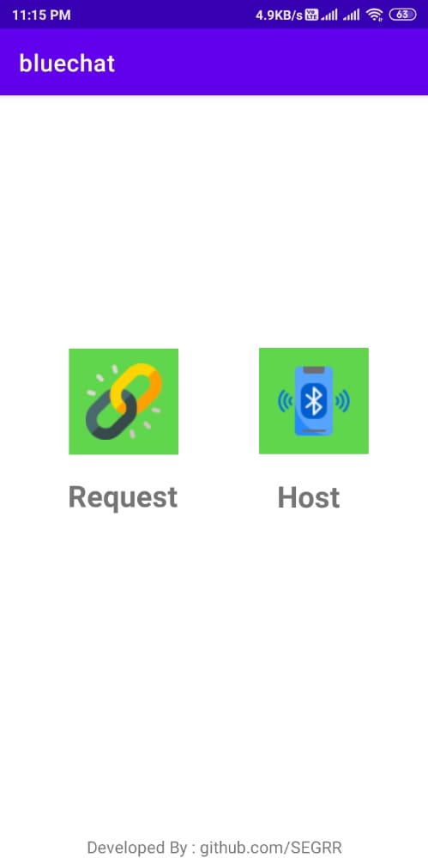

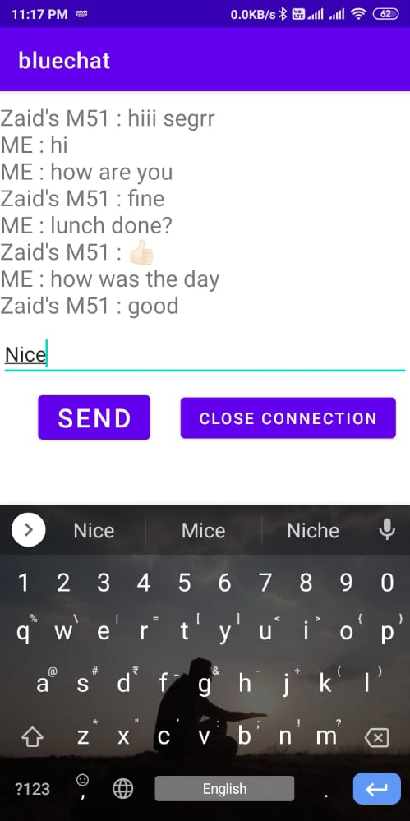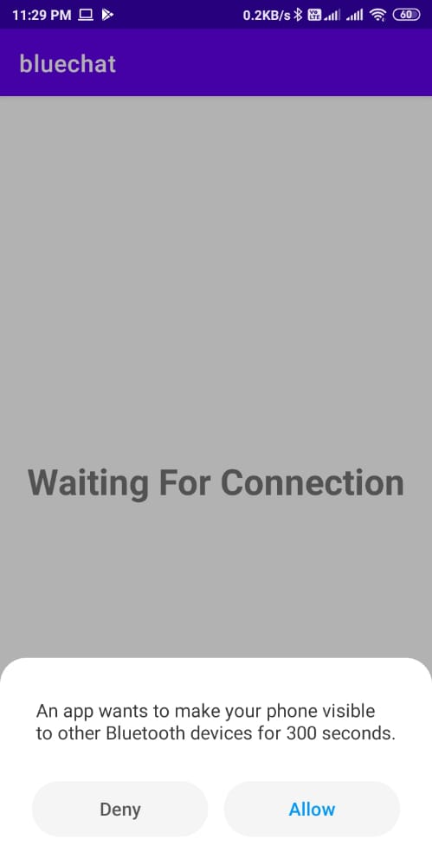

**7.0 Skill Developed / learning out of this Micro-Project**

1. learn to develop Android applications
2. Creating Activities
3. Access Bluetooth Adapter
4. Creating Bluetooth communication socket

**8.0 Applications of this Micro-Project**

Application of this micro-project is a mini messenger Application. Which can be used to communicate using Bluetooth. This app can be used when you don’t any details of receiver like phone number etc. It can be used in cases like small chat in a classroom, when you don’t have internet to use other messaging application

**9.0 Area of Future Improvement**

1. Improvement in GUI
2. More functionalities
3. Optimization in algorithm
4. Share opened PDF file on multiple devices

Conclusion

From this microproject I learnt do develop real life android applications. I understood all the basic concepts to develop android application. This project taught me how to retrieve files from device and display them. I developed good understanding of UI designing and creating application with many Activities.

References

|  |  |  |
| --- | --- | --- |
| **Sr.no.** | **Reference** | **Link** |
| 1 | BluetoothAdapter | https://developer.android.com/reference  /android/bluetooth/BluetoothSocket |
| 2 | Bluetooth Permissions | https://developer.android.com/  guide/topics/connectivity/bluetooth/permissions |
| 3 | Android documentation | https://developer.android.com/training/data-storage/shared/documents-files |
| 4 | RegisterforActivityResult | https://developer.android.com/training/basics/intents/result |